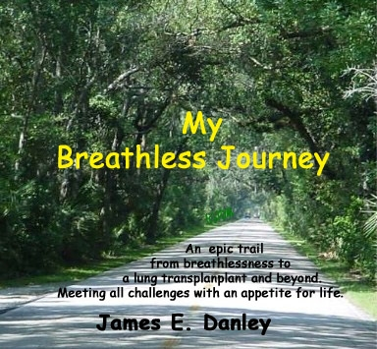

Contents

Chapter Page

1. The road back 2.
2. Family & relationships 16.
3. Welcome to disability 30.
4. What a surprise 35.
5. Get moving! 40.
6. My home away from home 49.
7. Tick tock - tick tock 59.
8. Wake up call 65.
9. Take a deep breath 78.
10. Live like you were “not” dying 87.
11. Check in time 93.
12. Keep singing 109.

Epilogue 115.

1
The road back

So much has transpired during the past seven years, yet the trip to my hometown washes it away in minutes. How intriguing life is, indeed no greater words have ever been spoken and yet, so quickly dismissed by the masses than, “your life can change in an instant”. Life being the interpretive word, I ask that you never take yours for granted. “An eternity is only a breath away” would also be a classic catch phrase that could best describe my new life, if I were asked to find a sentence to describe it.
As I sat at my desk, I had the oddest sensation to lean forward, as if fatigued and needing to sit down, realizing indeed that I already was. Time would go on, and little situations would occur, and then remind me once again that something was wrong, terribly wrong. How could something happen to Mr. never miss work?
Five years had passed since the first day in my current position with payroll/human resources; my perfect attendance record was a trophy to me, just as the previous fifteen years in my last position in management in the resort industry. My point is not to dwell on a resume history, more to the point, like so many I felt invincible when it came to common health problems.
Slowly it all seemed to begin with the scary shower scenes, none as obvious as the ones from the famous fright movies. Nonetheless these scenes were more frightful yet all the while suspenseful, until you experience it, “nothing” is more frightening than breathlessness, nothing. Perhaps one of the most frustrating effects of slowly suffocating is watching how other people take breathing for granted. We are so vulnerable, and don’t give it a moment’s notice. As time would pass, so shall my ability to inhale. I was learning that when I would exhale, a lack of elasticity in my lungs would not allow them to empty. Thus, the air left inside was useless, yet prevented me from inhaling fresh air. The humidity of the shower was enough to make the air moist & heavy, making exhaling even more difficult in these, the beginning signs of my having a problem. Foolishness can go hand in hand with feelings of invincibility, when combined the two can be downright dangerous & insane, in other words; when I was a teenager I became a cigarette smoker. While never a heavy smoker by most standards, perhaps a half a pack at my worst. This is the point in my story wherein I admit responsibility for my actions, being “cool” in my teens would indeed have a price to pay in my later years, and they were now here. My next step was to stop, “again”.
Over the next six months, and many nicotine patches later I was finally successful in my attempts to get the smoking monkey off my back. However, my problems seemed to be growing, my shower scenes were ever more frightening, and had now crept into my everyday life. I found myself at work, being asked after a trip walking down a hallway to a colleague’s office if I had been running. Given my breathless condition upon arriving there, it seemed in fact that I had. Even speaking on the phone I would have to pause to breath between words & sentences. Bending, crouching and filing would leave me winded, left in a cold sweat, and speechless.
We have all heard the term “Things happen for a reason”. Generally, it comes from someone who cares, and is trying to smooth a tragedy that affects your life. Perhaps every now & then, we create our own pitfalls while trying to make our own existence better. Well, a little of both occurred during the shaping of my new existence. As my breathless grew, so did my frustration of working 12 - 14 hours a day. Often, I found myself working from 6 am - 8 pm. I loved my work, and had developed countless friendships over the years while working there, and in my previous positions. I was overseeing the payroll & administrative management of over a thousand employees. Undoubtedly, a mix of too many hours & too much fatigue caused me to begin a search for a position less taxing (a payroll pun). I would be also misleading you, if I did not footnote that a recent sale of the company coupled with a long list of problems in its transition had also left me completely dissatisfied. While I had not yet attributed my fatigue to anything medical, I had stopped smoking, still hopeful, yet naïve in believing that it was responsible for any weakness I was experiencing.
Much to my excitement, I found myself with a new employment offer, just as my current employer was about to embark on a move to a new building much further from my home. The timing as such, seemed ideal to begin my new life. I watched in the wings as my friends & colleagues moved on in one direction, I moved on in another. As I often had recalled the old saying that appropriately applied to my situation, a new one came to mind. “The grass is always greener on the other side”, is one most have heard. During the next few months, I realized sometimes the grass was greener on the other side, because “it is over a septic tank”.
My new position was an epic nightmare, as soon as I learned I was hired by upper management to first spy on, and then take the manager’s job. Even before learning the responsibilities or duties, & procedures of a new business, or mine as her employee. I was greeted by distain and sarcasm every day by her. I quickly saw why this manager spit fire each time she spoke to me, it seems she was not as paranoid as I had first imagined. When I finally was informed of my “promotion” to her position, my morals would not allow me to “steal” a job in this fashion. I tendered my resignation and continued my search for “my perfect job”.
Days turned to weeks, then months as I found myself becoming fatigued mentally, and now more physically challenged. All in unison with a growing curiosity why I had not become more physically fit, since it had now been months since I had smoked. My breathing should have drastically improved as an ex-smoker, I found my life was changing quickly and becoming difficult to dismiss the need for my doctor’s intervention and opinion.
Dr. Hays has been my general practitioner for many years, originally an easy job with a patient that never became sick. Within minutes, and following a brief interview with him, he had already guided me in front of his in-office x-ray machine. Upon reviewing the apparent advanced progression of the lung disease on my x-rays, his immediate reaction was to send me to a pulmonologist, (the first new word in my soon to be ever increasing knowledge of medical terminology). Meaning, I was about to meet my first lung specialist.
My history with Dr. Tai, my pulmonologist was to be brief, as I credit him completely for giving me a diagnosis quickly. Many would later say it took months or years and many doctors to identify their identical rare disorder. In fact, most are miss-diagnosed with emphysema when presented with the symptoms I had shown. The largest part of this medical mystery was that it was more common for individuals with my amount of lung damage to be in their seventies or beyond, I of course was 39.
After a simple blood test, I was called back to the doctor’s office in November of 1999, to be presented with the news that would transport me back in time. As silly as this may sound, I felt as if I was in an episode of the once famous medical drama television show Marcus Welby M.D. The exception of course was that “I” was the patient being told that only a lung transplant could save my life.
My reaction was a blend of numbness and relief. I was being informed that I suffered from Alpha-1 Antitrypsin Deficiency. A hereditary disorder that is abbreviated in medical terms as A1AD and in lay terms as “Alpha-1”, for simplicity throughout my story I shall also refer to it as such. Alpha-1 Antitrypsin is an enzyme that is produced by your liver. In normal circumstances, the enzyme is released into the bloodstream, and travels through it, until it reaches then cleans & repairs your lungs of anything unnatural. As such, Alpha-1 Antitrypsin “deficiency” is when the enzyme is either not produced in your liver, or it is not being released. In those cases liver disease is occasionally diagnosed, and a liver transplant is then also your only treatment available. In either case, it causes your lungs to deteriorate from any unnatural causes such as smoke, aerosol, dust, smog, fumes, etc. As such, Smoking did not cause my illness, but certainly did not help me either. Many years of favorite hobby, woodworking & furniture building had caused irreparable harm as well. Largely, the sanding & use of sealants, and stains were part of my demise. The physiological numbness most likely came from trying to figure out what the doctor had called my terminal disease. To conceive of a transplant of any kind, much less my lungs was mind bending at best. Also, I was to learn later that such a transplant ranks more difficult than even a heart transplant, since lungs are simply a thin tissue, versus the heart which is one large muscle. Another hurdle would be to first pass a rigorous test of Mental & Physical standards & requirements, before I could be approved to be placed on this “life saving transplant list”.
As if a blessing, despite my doctors use of the term “terminal disease “, I only heard that what I was being told was not of my impending death (as some may perceive the glass as half-empty). In my mind I took everything the doctor had told me and colored it in a positive light, meaning a lung transplant would save me, not that a disease was going to take my life. One must also realize I had gone through months of secretly imagining I had lung cancer, as my breathing became more and more a luxury (even later a doctor had compared my breathing to sucking air through a coffee stir straw), so any hope was an inspiration to me. To this day I excel in concentrating on the positives in my life, yet never ignoring the facts at hand.
If I found sadness in what I was about to go through, besides the obvious hardship it placed on my family, it was the fact that someone would have to die for my transplant to take place. To summarize, my survival was dependant on being approved & placed on the transplant list, as well as another family’s loss, another life was in peril. Physically, it would demand consistent rehab workouts all while trying to slow my breathlessness.
Evermore obvious, was the fear I imagined seeing in my family’s eyes. No words can describe this emotion; it can only be described as love in its truest form. Your spouse, children, brothers, sisters, parents, aunts, uncles, cousins, and friends share it with you. The fear, sadness, hopefulness, helplessness, pain, offers of people wanting to take your place, just wanting to give anything of them self. Some had even offered one of their own lungs. This makes you love them even more, while being awash in embarrassment over the attention and it is priceless.
As mentioned above, my history with this pulmonologist would be brief. I fully was impressed with his quick analysis of my disorder but was equally in distain for his lack of positive attitude regarding my imminent death, or knowledge of A1AD. In brief, my doctor told me he had no information on the disorder that I would be best served to go home and look it up on my computer, since he did not even have one. He stated in reality I should just go home and lift weights, as likely nothing would slow its progression. Further stating he had only one patient with this rare problem, and he was in Atlanta awaiting his own lung transplant. He was however, aware of a special medication called Prolastin, to which he would have to write to my insurance company for special payment authorization. It carried an amazing cost of $1800. Per dose with a weekly need for an Intravenous (Iv) infusion. Furthermore, it took 50 blood donors to produce each weekly dose, thus the explanation for the cost. In addition, I gained newfound respect for those that donate blood; this is one of the many ways their efforts carry on to indeed “save lives”. I hereby thank each of them for their heroic & humane efforts.
The next phase of my journey would involve Pulmonary Function Tests, (known as a P.F.T.). Among these tests, one crucial measurement is the fev1 (aka: Forced Expiratory Volume). Basically, this is a test that measures how much air one can blow out in 1 second into a mouthpiece & tube connection to an electronic monitor. This is a test that one becomes very familiar with, seeming hundreds of times over a period of 7 years in my case. The air is measured, and compared with someone of your sex, height, and weight to approximate your percentage of lung function. This percentage quickly informs you, and your pulmonologist, of your current well being. In my first test, my fev1 was 31% (equaling 1.25 vs. 4.00 liters of normal airflow (and based on sex, age, weight) of normal lung function, in the period waiting for my transplant it would drop to about .15%. (or .60 liter).
There were to be so many changes in my life, I could not possibly understand their impact on my future when I had just been informed of my life-threatening situation. In all honesty, the doctor had called it a terminal disease, but I was not ready to accept that terminology.
It is more appropriate to compare the day you receive such news to one in which you have planted a tree in your front yard, (or perhaps your backyard), depending on whether you plan to hide your news. Even though you may feel you need a “truck” to bring it home, its impact on your life spreads like branches the more you ponder on its impact. Day by day, months into years, the branches continue to spread. Ironically, you also begin to realize how much your life (or branches) has been intertwined with others.

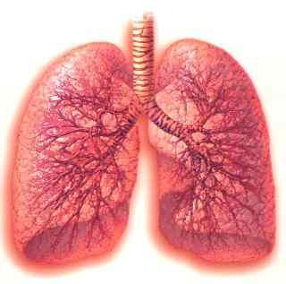

Ironically speaking of branches above, please
See next page for:

A comparison of a
healthy versus diseased lung 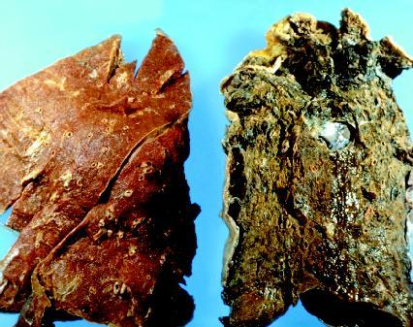
2

Family & relationships
My first priority was to approach my loved ones. Nancy, my spouse of nearly twenty years had been already with me in the doctor’s office. How could I imagine what was racing through her mind, I couldn’t? However, even in our years together, and up to this moment somehow, I could only begin to know the impenetrable force and strength she beheld. In her soul she possessed the powers both medically & lovingly that would sustain me in so many countless ways spiritually & physically. In a way, her being in the office with me eliminated my having to find a way to tell her all I had just learned, but in a matter of minutes I would be facing my two children. Soon to follow would be all whom I also love and treasure as family & dear friends.
Trying to find the words to calm yet being forthcoming with the truth as you best know it. To look into their eyes, or hear their shaking voices over the phone, the fear of telling my family gave me something I still hold precious today. Perhaps a gift from my Lord was a positive spirit that grew inside me like a light, which stills glows today. The only way to approach someone, without causing them to worry was to also show them my optimistic spirit & strength.
Please know, I always knew my diminishing odds of survival, and I was not silent in terms of being honest with any questions asked, or giving facts I had, or would learn along my new journey. To the contrary, I have always felt a need, even a responsibility to share whatever I could with anyone who needs help with dealing with “Alpha-1 Antitrypsin Deficiency”, or any similar disability. This is exactly why I wanted to get my story, my thoughts, down on paper.
A future issue to trouble me would be to wonder how, or if, I should reach into my past calling old friends, co-workers without sounding like I wanted something. In my deepest inner self, I wanted to show only strength, but I also wanted the world to also know of my situation. I was still here, and I did not plan on going anywhere.
Nonetheless, one can’t help but find themselves on every holiday, or annual occasion of being reminded it may be their last. Secretly memorizing each special moment, in a way you might not have otherwise thought about. While all these life changing issues where pounding away at me, only 20 minutes had passed. I was just ending my drive home, just imaging at least my next two or three years while waiting on the transplant list, If, in fact I was approved for such a list. As well as the resounding echo of having just been told, “I had only these years left, two at best if I did nothing”.
My children Crystal & James (then 18 & 13), were waiting at home, perhaps unaware I had even been at the doctor’s office, or even referred to a specialist. I felt that one does not instill concern on their loved ones until the time arrives that all hope to the contrary is past. Obviously, that time was also here.
In the entanglement of emotions, I would carry throughout my journey, Pride of how my children were carrying their fathers sickness quickly rose to the top. I believe down deep that they feared my death after our little talk arriving home, how could they not? Among inherited concerns, we all likely share the fear of parents passing. Anyone reading this that has lost their parent (s) will have dramatic memories of their own, for this I offer my sympathies for your losses. My point is, I am still blessed to have mine and to have read the hearts of my children is impossible. When asked years later, where their impressionable strength came from, they only replied that my lack of fear gave them their strength. Sometime in the future, I became the honored father when reading various tributes from these amazing young adults. In each their own spectacular way, they have honored me. My son had written a school paper which he titled “my hero“, wherein he described my trials thru his admiring eyes. A tribute by my daughter on a web page respectful of the courage, and the ways my wife, my son, and I had risen to meet each financial & emotional challenge, was equally enough to make any father proud. By this time, she was living close by, yet separately. But she made it a point to be involved in our lives whenever possible.
While reminiscing in my comments above, the harsh truth remained that I had still had not spoken with anyone outside my family at home, and my conversations would not be getting any easier. Dialing my parents (Mary & Ed) & brothers (Tim & Joe) on the far end of the country was to be my next challenge. Clearing the lump in my throat only served to make my breathing more difficult, I dialed. My father, the source of my natural stability, answered the call. Somehow, after our courtesies were exchanged getting my mother on an extension gave me a peace knowing they were together, for each other for what I was about to tell them. I had the task before me, of explaining that such a rare disorder was an event in itself. I am uncertain if I first explained this was a hereditary disease. Certainly, all that would stand out through the muffled confusion would be my lung transplant, or death.
After the shock of such a call had settled in, and the course of my medical steps would became clearer in the following days & weeks, I would share more specifically. I do know that after I explained that this was a hereditary disorder, largely to have my family tested, it grew into a guilt my parents probably never found a cure for. This was a side effect I wanted to cure for them, a thousand times. Through no knowledge, or fault of theirs, this is a parent’s unspeakable burden. I learned this all too clearly as I also had my children tested. I found a relief to learn they would be safe from this curse, but it would be still a threat to my generations to follow, as they were carriers.
As I stated, throughout every conversation with family, and all whom were in our family tree, I pleaded with each to be tested. None could be more difficult, or forever regretted, than with my dear twin brother Joe. He had been through repeated occurrences of pneumonia since childhood. As years passed, his breathing problems had grown with him, in addition to many other painful problems, including deep skin ulcers. This news prompted him to be tested for the Alpha-1 enzyme, only to find he now faced the same situation as I, sadly, his results came back as positive. In no uncertain terms, we all now realized I, and all of our family now faced the loss of my twin as well.
My next call, to my older brother Tim was nonetheless be no easier. His love and support would only grow as time grew with us from so far away. He would now face the challenge helping me keep my twin brother & parents strong. I would need him then, and into whatever happened in the future to be the rock my family would need in my absence. My spirit would remain strong, I had to ask this of him as well, from their homes in Michigan, to mine twelve hundred miles away in South Florida. As a blessing to us all, he did not have the missing enzyme that had so suddenly become the monster in all our lives.
Next, my half brother Ron was no exception with all his efforts to keep in touch with me from afar. It’s ironic how small the world becomes when things seem to go wrong. 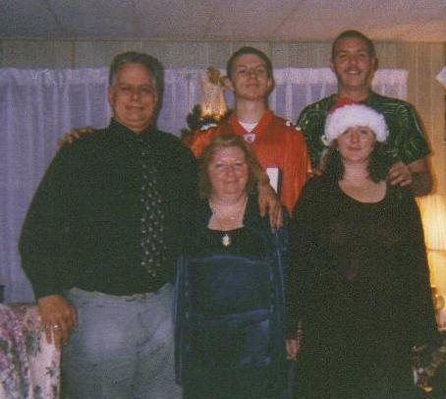
Myself / James (Son) / Brandon ( Boyfriend)
Nancy (Wife) / Crystal (Daughter)

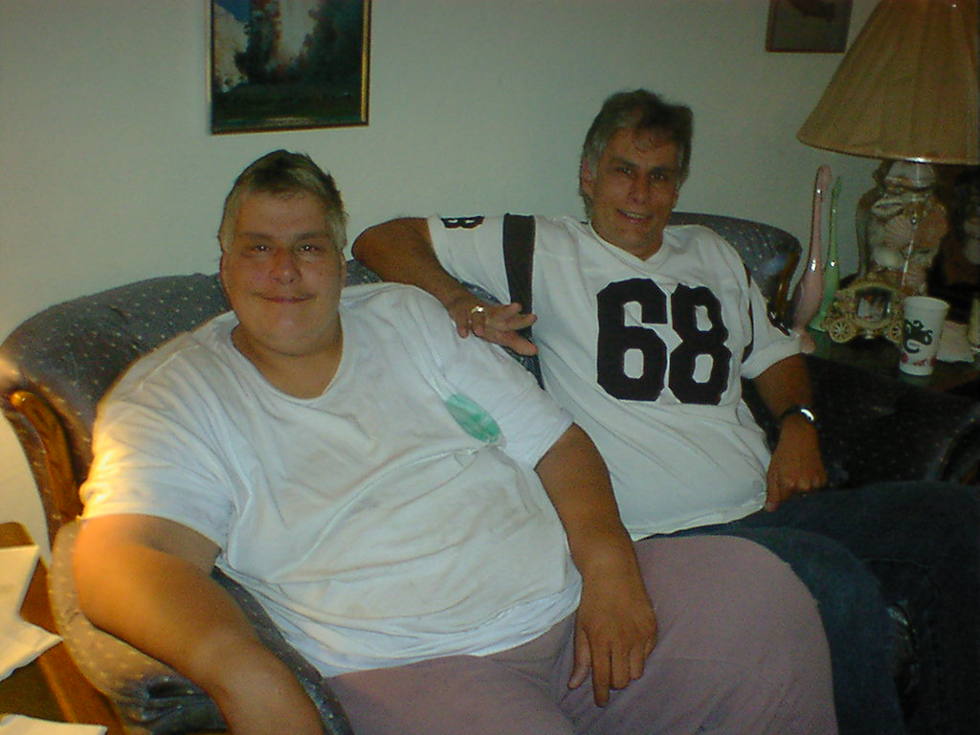
Joe Myself
(My twin Brother)

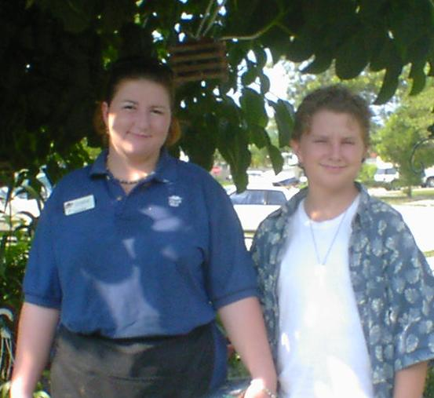
Crystal James
(My young adults)
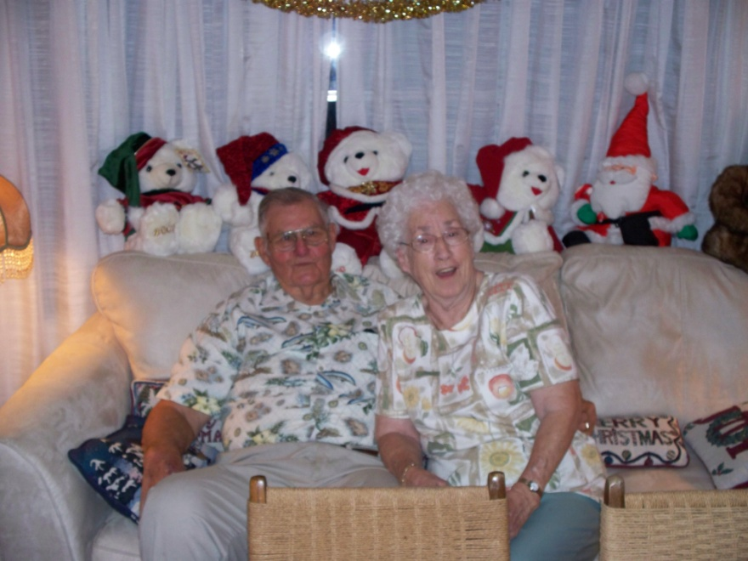
Ed & Mary
(My parents)

Call after call, to so many loved ones & friends was a combination of awareness, compassion, confusion and a hidden fear. The first of these calls were to my in laws. If ever a family loved a son in law as their own, it has been Al & Betty. The parents and extended family of my Nancy have showered me in all the imaginable love and assistance I could have ever hoped or dreamed for.

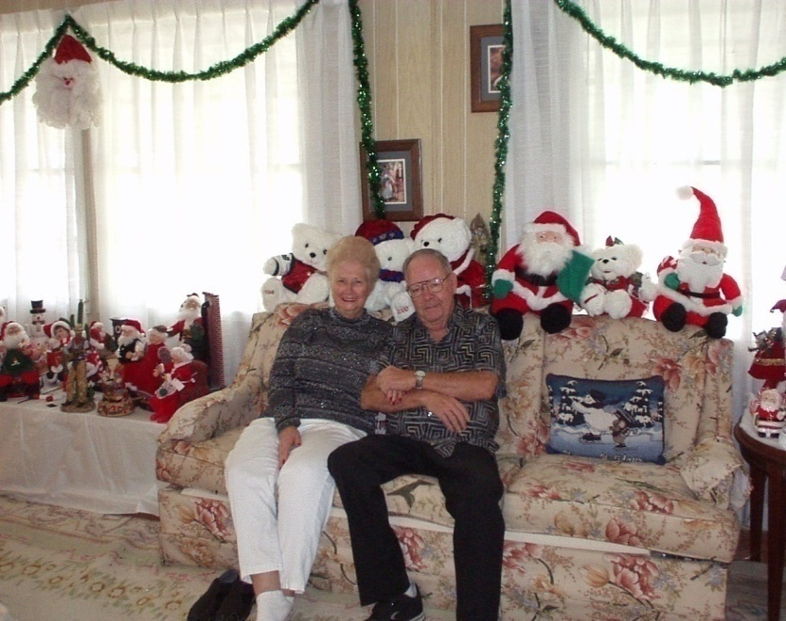
Betty & Al
(My in Laws)

As a large part of many of my phone calls, I wanted those possibly threatened by this hereditary problem to be tested, only to possibly be treated before they would reach the stage of the disease which was beyond treatment. Caught early enough, as in the situation of a child, one could possibly alter their lifestyle and surroundings to indeed “save their very own life” by monitoring what they breath.
One terminology I still have trouble with is the reference to this being a disease. Strictly because once more, it is a missing enzyme that as such fails to repair normal deterioration to one’s lungs.
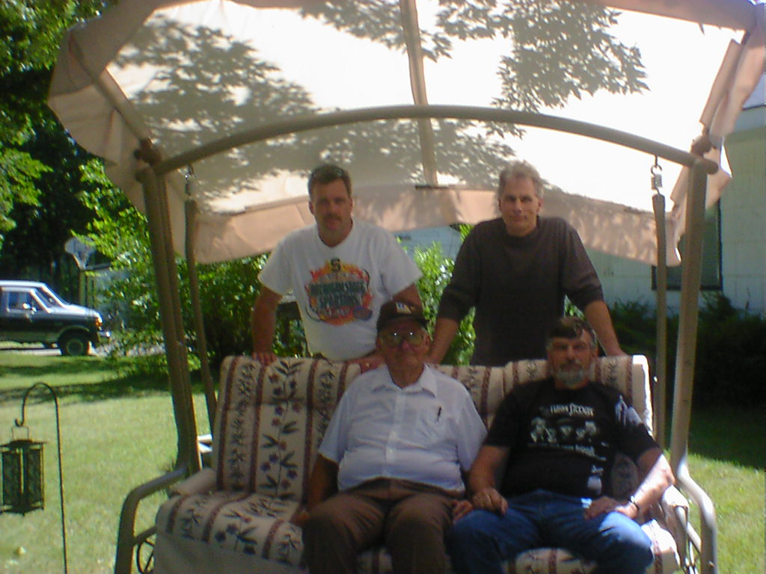
Tim Dad Myself Ron
(Dad & Brothers)

The oddest dilemma was whether to call my longtime friends. First, these are the cornerstones of my past, my youth, and my career relationships. Those that have seen so many phases of my life, I just wanted them to know, and deep down should know, if things turned differently than any of my intentions to survive. Perhaps they should know also, their prayers & support meant the world to me. I am not naïve; I was ready to accept all the support I could gain.

3

Welcome to disability

The longer my job search became unproductive, the more I realized I was walking uphill towards a status symbol I am embarrassed of, even to this day. Earlier in my story I stated we are always told “things happen for a reason”, likely my prolonged job search was no exception. As my daily schedules began turning from interviews to doctor’s appointments, medical procedures, & physical rehab, I found less and less time to sustain a normal professional life. Coupled with a fondness for an income, and my consistent declining ability to breath I approached the realization that I needed to pursue a disability income from the social security program I had contributed to so faithfully my entire career. While many changes and events in my life would bring embarrassment in the years to come, I finally came to the acceptance that Social Security Income was an insurance program I had paid into and should not be something to be ashamed of.
Upon leaving my previous employer, I had the good foresight to maintain my insurance under a cobra plan, as most might know this is when you continue the coverage but pay the total rate the employer had agreed to with a health provider. While an employee normally pays a portion of a medical premium, the employer pays the remaining percentage. At one point in the duration of my employment, my manager offered me a perk verses an increase in my salary, apparently keep payroll numbers lower, for as he put it “a job well done “. The company stopped deducting the portion I had been paying for my family coverage. I mention this because it became a huge difference when I obviously began paying my premiums in total.
I had left them with only the intention of continuing the career I was so proud of, before I had become aware of the medical reasons for my situation. Keeping up with your health premiums while your income becomes nonexistent is a magic (but necessary) act. It becomes amazing to later learn that there actually is a law favoring health insurance companies that raises your premium to 150% of the rate you were paying with the group, prior to being determined disabled. As such, my portion of the monthly premiums went from zero, to $1200. Then increasing to $1800 monthly, after the 150% rate hike. Equally ironic was that $1800. Also, was the cost of the weekly IV of Prolastin medication infusions I was now taking. These procedures were also being administered & taught by a nurse in my home. Karen became a fountain of information to us. It was also true that, the weekly visits were just one more minor change I would accept to slow the deterioration of my lungs.
It was obviously imperative that my health insurance not “ever” stop considering the mountain of costs I was about to climb. The financial light at the end of the tunnel would be the lure of automatic Medicare coverage, once I had sustained my disability status for two years. How coincidental that the waiting list for lung transplant recipients was also two years.
Oh, what a busy time it would be, beginning with a truckload of red tape in the form of applications. Social Security disability is a blessing and a curse. All through the lengthy process you will be asked to show your past professional & medical histories. You will show how you are unable to perform in the capacity you have in the past, doing what you know and loved. You will prove that there is little, or no hope for improvement in your condition, as well as the expected decrease in your abilities in the coming future. If you had not yet came to terms with your situation, putting it all on paper for the government is a sure fired wake up call.
Next, your medical history will be scrutinized and evaluated by the S.S. Administration. If their findings are in order, you will begin meeting & testing with government doctors that (hopefully) agree with all your previous medical evaluations. The process is a labor, but a necessary one indeed to eliminate fraud in our society. It’s a double edge sword since you simply would like your old life & income back, instead of the stigma of being confirmed handicapped. Further adding to your frustration is to be told by everyone, that no one is approved the first time around, and all steps would have to be repeated on an appeal process. One of my breathing tests during the application process showed a computerized determination stating: “lung age” 157 years. I am to this day stunned to recall seeing that line, and wonder who in the world the computer had to compare me too. Indeed, it was enough to approve me. Finally, in May of 2000, an income would help to sustain me, contributing once more to the family budget, sustains one’s pride. Moreover, this cleared the way for Medicare insurance coverage also to begin in two years. Once I got the tag to hang from my mirror for parking, indeed it was official. The only question that remained was: Would I ever get used to it?

4
What a surprise
I would be remiss in my responsibility to you, or my intended purpose for writing this book, if I did not emphasize that even if someone does not suffer from A1AD, the similarities in people with other breathing difficulties are too close to ignore. As such, much of the information to follow could assist any member in a family of ailments under the heading of C.O.P.D. (Chronic Obstructive Pulmonary Disease), which makes it hard to breathe. Coughing up mucus is often the first sign of C.O.P.D. Chronic bronchitis and emphysema are common causes for this. A1AD is sometimes even referred to as hereditary emphysema. In pulmonary therapy, they begin by telling you they are going to “teach you how to breathe”. It almost sounds ridiculous to hear such a thing. But in actuality most people have no idea how they breathe. It’s something that is taken for granted, yet every moment in your life depends on your next breath.
Factually, more know how their car engine runs, than their own body. Your airways branch out inside your lungs like an upside-down tree. At the end of each branch are small, balloon-like air sacs. In healthy people, both the airways and air sacs are springy and elastic. When you breathe in, each air sac fills with air like a small balloon. The balloon deflates when you exhale. In C.O.P.D. patients, your airways and air sacs lose their shape and become floppy, like a stretched-out rubber band. Consider that if you have thousands of these balloons, their surface area is increased. With C.O.P.D. the air sacks become larger and fewer, thus decreasing the surface area, thereby reducing the oxygen supplying your body. Cigarette smoking is the most common cause of COPD. Breathing in other kinds of irritants, like pollution, dust or chemicals, may also cause or contribute to COPD. Quitting smoking is the best way to avoid developing COPD.
When dealing with breathing treatments, inhalers, etc. can make you more comfortable, but there is no cure. C.O.P.D. is characterized by an obstruction to airflow that interferes with normal breathing. There are other obstructive or debilitating diseases such as:
- Emphysema
- Cystic Fibrosis
- Bronchiectasis
- Pulmonary hypertension
- Pulmonary fibrosis (e.g. sarcoidosis, IPF, silicosis)
Factually speaking:
- COPD is the fourth leading cause of death in America, claiming the lives of 122,283 Americans in 2003 and the number of women dying from the disease surpassed the number of men.
- This is the fourth consecutive year in which women have exceeded men in the number of deaths attributable to COPD. In 2003, over 63,000 females died compared to 59,000 males.
- Smoking is the primary risk factor for COPD. Approximately 80 to 90 percent of COPD deaths are caused by smoking. Female smokers are nearly 13 times as likely to die from COPD as women who have never smoked. Male smokers are nearly 12 times as likely to die from COPD as men who never smoked.
- Other risk factors of COPD include air pollution, second-hand smoke, history of childhood respiratory infections and heredity. Occupational exposure to certain industrial pollutants also increases the odds for COPD. A recent study found that the fraction of COPD attributed to work was estimated as 19.2% overall and 31.1% among those that never smoked.
- In 2004, 11.4 million U.S. adults (aged 18 and over) were estimated to have COPD. However, close to 24 million U.S. adults have evidence of impaired lung function, indicating an under diagnosis of COPD.
- With reference to Alpha-1 Antitrypsin Deficiency, it is estimated that over 100,000 have the disorder, while less than
- Only 10% are aware of it, until everyone is tested.
- Statistics provided by the American lung Association fact sheet.

5

Get moving!

So much needed to be done, first would be to find a new pulmonologist with a familiarization with AA1D. I wanted to find a doctor with multiple patients, experience, and a positive outlook in dealing with my disorder. My home care nurse had been administering Prolastin to other A1AD Patients. I was able to find the perfect local Pulmonologist through her recommendation. Dr. Warshaw was crucial in monitoring, organizing, implementing, and prescribing everything from pulmonary rehab to breathing tests, and my prescriptions.
I wish I could say all I had to do was hold on for dear life and wait, but not a chance. Seemingly, hundreds of miles of treadmill rubber, lied in front of me. In addition, weight lifting, educational lectures, and many other forms of exercising would be major parts of my new existence. Additionally, you are taught to learn to properly breath (as mentioned earlier), and how to minimize your shortness of breath through various techniques.
All education was under the heading of pulmonary rehabilitation two or three times per week. While fighting my body’s constant yearning to give up. This was one more example of not being able to imagine how I could have continued a professional work schedule. Keeping in mind, I was also receiving an IV once a week at home. More specifically, by this time I was actually injecting a needle directly into my chest for the Prolastin. A port had been inserted into my chest, hooked to direct lines into my main arteries, yet invisible under my skin. This was done to save the weekly accessing, and possibly collapsing of my veins. Each IV would be inserted into the port, for any multitude of reasons in the future. This is something one should seriously look into, if lifelong vein access is ever required for whatever cause.
By attending education classes, you learn many things about your lungs. For example, the following topics will be discussed: what is wrong with your lungs, what your medicines do, when to call your doctor, and how to keep from being hospitalized.
During group meetings, you will meet others with breathing problems. This gives you time to share concerns and approaches to living with breathing problems. The exercise classes will help you be more active with less shortness of breath. Usually, you will be exercising both your arms and legs. In most cases, your pulse & oxygen levels should be monitored by a physical therapist during excursion. The classes will help you feel better and become stronger by helping you get into better shape.
Maybe the biggest benefit of all, shall be when you realize you’ve met some lifelong friends in the process. Other matters of attention involved what I ate, and certainly my air quality by the use of air purifiers at home.
Somewhere between receiving my diagnosis, and being taught to breathe again & exercise, I began the best part of my rehab. Music had always been a part of my life, but how amazing that I now began to sing. There are so many physical advantages to singing when trying to build up one’s lungs. Followed by the smile it would, and still does put on my face. While beginning small, I soon became a karaoke soundtrack addict. Music has kept my spirits high, while building up my diaphragm. In time I created a music cd as a gift to my Nancy, however repeated requests for eventually hundreds of handmade copies turned them into an avenue towards fund raising. I will be forever grateful to all that expressed an appreciation for my singing. I will continue to sing as long as my Lord continues to find ways to give me the breath to do so. If you do not sing, another popular tool is the harmonica. It accomplishes all the same breathing & diaphragm benefits, while putting a smile on your face.
Unfortunately, a necessary evil while trying to meet a never ending list of medical expenses has indeed required fundraising. This topic brings such a combination of emotions to mind, always embarrassment, gratitude, the realization of true friendships, and shyness just to name a few. Foremost, there was always a need to make insurance premium payments. So many other costs are never covered such as medical & pharmaceutical co-pays, travel costs soared in the thousands and continue today for basics such as food, gas, lodging, car payments & auto insurance, and untold misc. expenses to & from the transplant center. Years later, the 600 mile round trips still will be taken every three months for evaluations.
Prior to beginning collections, finding an accredited organization monitored by the IRS was critical. In my case, I selected the “National Transplant Assistance Fund“, or N.T.A.F (www.transplantfund.org) organization to help donors realize that their donations are scrutinized for only medically related costs. Their donations are also honored by the IRS as tax deductible. Donors would simply go to the website and look up my name, or by calling 800-642-8399, all event collections would be forwarded to them as well, and monitored under the same scrutiny.
Earlier in the story I introduced you to Al & Betty as my In-laws. They are so much more than, friends, loved ones, and amazing soldiers in my war. Being national square dance members, they organized dance after dance to fundraise and bring attention to this hereditary misfortune. While thanking them, I also reach out to all that danced their way into my heart along the way. Throughout every event, we would & continue to promote Organ Donor Awareness, and A1AD testing. With our goal being to save as many lives as possible along the way.
I can only pray that the dear friends, parents, family members, and hundreds of giving strangers that stood beside me during each of these events know how they impacted my life. Getting through these times would show me how blessed I was to be loved so deeply, and by so many. This balance of humiliation, embarrassment, and gratitude is something no one should ever have to experience. But the efforts all around you, and for you, are something words can’t describe. “Thank You” just seems to never be enough. Many individuals helped throughout these events, yet consistently my parents, in-laws, spouse, son, daughter, and friends such as Michelle deserve a special “Thank You” for having always appeared at every event.
As previously mentioned, I was receiving the drug Prolastin. The process for receiving this as well as the supplies to administer it was received through the efforts of several organizations. Bayer provided the Prolastin, which although referred to as a drug was more the product of compassion. I say this because it took 50 blood donors to produce each dose. While I briefly thanked them earlier, I will try to describe what this “collection” consists of. A small portion of Alpha-1 Antitrypsin is collected from each blood donor, processed, purified, and freeze dried. Prior to injection it is mixed with saline and administered into the bloodstream to replace the enzyme my body was not providing to my lungs. In the process of receiving the supplies necessary for the process, I began receiving calls from the AlphaNet (http://www.alphanet.org). I would receive monthly calls from a coordinator; Marta was more beneficial than she will ever know. While she handled all of my Prolastin & intravenous supply requirements, she also led me down many paths to begin relationships with the doctors & friends that would change my life. Months later, Bob would take her place, both of which I shall always admire for their knowledge, assistance, & commitment. The Alpha-1 Association Support Group will always continue to be a large part of my physical & mental well being. We continue to meet monthly with many other Alpha survivors. These folks have become dear friends whom I shall always share a unique bond with.
While I have shared laughter with this amazing group, we have also shared tears over our losses. They are shinning reminders for the need to stop the A1AD destruction before any more losses are felt.
Almost one year to the day from being diagnosed, while I was still trying to make my lungs stronger, our hearts broke one December morning in 2000. My beloved twin, Joe suddenly lost his battle before he truly had a chance to mount his challenge. Despite our efforts to take on this disorder together, a blood clot snuck into his lungs and he was carried away from us so unexpectedly. His spirit gives me one more reason to carry on, yet it will be a lonelier battle without him, his beautiful smile, and his laughter. Every birthday feels hollow when you lose a twin. I can only pray that God took him so quickly, to spare him of this journey wherein his outcome was realistically as uncertain as mine.
Exactly one year to the day later, we then lost my cousin Jeff. Time did not allow us to know if he too was affected based on hereditary. However, his liver may been involved which emphasizes once more the need for testing throughout ones family tree. Whatever the cause, the world again became a smaller, lonelier place when these two voices & hearts were silenced.

6

My home away from home

I mention the Alpha Support Group for several reasons, besides my friendships. My association with them triggered a chain reaction of events. First they provided the name of the Director of the Alpha--1 Research Program, Dr. Mark Brantley at the University of Florida. His unique understanding of this disease, and continued testing shall one day be the answer to curing this hereditary nightmare.
I am also proud to have been allowed to be the first to donate my lung for testing in his laboratory, following my transplant, for that purpose. The link I had with this Doctor, set in motion the beginning steps for getting on the National Registry for the Lung Transplant list. Dr. Baz, the Director of the Lung transplant team at the Shands Hospital at the University of Florida agreed to meet with me. That meeting obviously changed the course of my future, as it gave me hope for my transplant.
If I felt that applying for disability was involved, it was only because I had not yet begun the process of gaining acceptance on this treasured list. Every conceivable medical test was about to be performed on me, to make certain I was in ’perfect’ condition void of any other medical problems. One large reason for this was that the transplant process consists of tradeoffs. When one problem is cured, another likely arises as a side effect. Primarily, I was about to lose most of my immune system in a delicate balance to stay alive following my surgery. As such, any hiding monsters in my body would be virtually unstoppable without the defenses of my immune system. Just as amazing, if one is curious as to ask why my immune system then had to be suppressed. It was to prevent it, from attacking my new lung. If the body is successful in its attempts to attack the new organ, it is referred to as being in rejection. In addition, once my immune system was compromised, I could no longer be around people in close proximity. For any sickness they may pass, would make me easy prey. Once more, this eliminated the ability to perform in a typical office environment, even after my transplant. It was also true that I would have to wear a mask in public, if within 3 feet of the general population in many circumstances. In short, a common cold could lead to my demise.
Following my first visit with Dr. Baz, I was invited back for a Three day marathon of the medical tests mentioned. In addition, I began a series of psychological tests to determine my mental state. This would be to evaluate whether I could “handle” being a organ recipient, as it also has an effect on the patient. Once all mental and physical tests were performed, the financial aspects of such an undertaking would be scrutinized. This was to determine if we could sustain a lifetime of costs related to my care. Briefly, these costs would include those mentioned regarding fundraising. Foremost, verifying insurance, or that any other financial means would be in place to cover the estimated $ 250,000 surgery, and 3 - 4 week estimated hospital stay. I would also have to make preparations for a two - three month stay in the area for physical rehabilitation once I was released from the hospital.

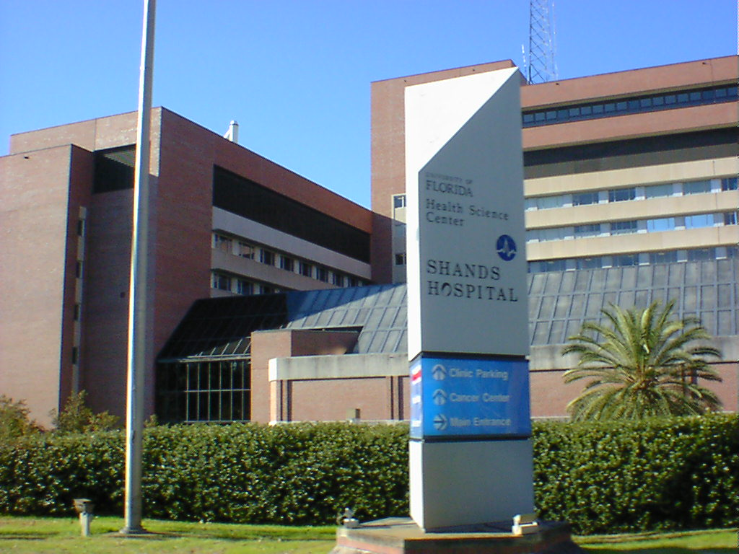
Shands Hospital @ University of Florida
Now, all we had to do was wait. Twenty two months had passed since that day in November, 1999, in Dr. Tae’s office when I received my diagnosis. Weeks would go by awaiting the medical board to review my file. The date was set when they would make their decision, for 9/11/2001. Yes, this date had originally no particular significance to anyone. I sat by the phone waiting & praying that morning. When it rang, I recall instead being told by a relative to turn on the television. As I did so, I watched with the world as the United Nation towers were attacked then fell, and America went to war. I never got my phone call that day, as I would later find the board meeting had been canceled. As with major events in history, we are asked if we remember what we were doing when they occurred, I certainly will as well. Days after I got my phone call, and received the news that could have amounted to a death sentence, instead I was told yes, you’re getting a lung transplant, you’re on “The list“.
In the months to follow, I would be monitored by the team, and make periodic trips from my home 300 miles south. I would be directed to maintain my physical rehab, and continue to perform breathing tests to monitor my fev1 level. At this point I had dropped to 20% of normal lung function. However as miraculous, I still was not (yet) on Oxygen. I can’t help but still wonder if my continued singing was also benefiting me in this way.
Amidst the many preparations involved with having to leave our home at a moment’s notice, was the realization we would be gone for possibly three months. I can’t begin to stress how Nancy’s care, perseverance, and her income helped to make all this possible. Just as crucial would be her having to make preparations to leave her business and accompany me on this wild adventure when the phone would eventually ring.
The next big preparation would be to plan transportation to the transplant center, when the call would come through. I would have only a few hours to begin prepping for surgery. Since it’s a five hour drive, arrangements had to be made in advance to fly. One of the hardest parts of all this to deal with for me, was dealing with the life ending event that would take my donor.
One more in a string of miracles to touch my life, was my association with an organization Angel Flight. This is a group of pilots that also own their own planes. They volunteer their time, planes, fuel, and good hearts to transport transplant patients around the country. With the processing assistance of my team, I was approved to also be on the Angel flight roster. I was assigned three pilots in my local area; this was in case any of them were unavailable. Tentative plans were made with each pilot, and yet another building block was in place for my big day. Next, I was set up with a beeper to carry at all times, (yes, people once carried beepers). I was informed that the average wait on the list was two years, and the wait was on.
I would be asked many times in the future, what had caused my problems. Eventually I produced the following poem to help answer the question, (writing poetry is also one of my many loves) to describe what caused this disease, and where my heart rests amidst my many emotions, but mostly, to honor my still unknown hero:

My Precious Breath
I noticed a problem breathing,
so I went to a doc to see,

What was causing this weakness,
what could be wrong with me?

So with the doc I talked, as he quizzed,
poked, and measured,

Until he had a name for the problem,
affecting the lungs I treasure.

Alpha-1 Antitrypsin deficiency was a
big & scary name,

I knew that day my life would change, nothing would be the same.

But somehow I felt in control, and
believe it or not I’m relieved,

My first fear was an immediate death, so indeed its good news I received.
Since my reaction was relief, and
my constant attitude is upbeat,

I will accomplish what I must to survive,
leaving no option of defeat.

Simply put, to describe this problem,
there’s no enzyme your body makes,

To clean your lungs of smoke and junk,
so your lungs deteriorate.

And at the same time, I am not in denial;
I know my breathing will diminish,

Soon I’ll need a lung transplant when
the ones I have are finished.

To conclude, I now give thanks to
an unknown organ donor,

How could I ever convey a tribute,
that is worthy of your honor.

Indeed you’re such a hero,
as I express my thanks here with such sorrow,

You’re forethought of passing on life, will give me many tomorrows.

I am pleased to say this poem found its way into several national publications. As well as honoring my hero, it was also used to promote awareness of the following areas.

* Organ donor awareness
*Alpha-1 Antitrypsin Deficiency awareness
* Stop smoking campaigns

Someday I hope to get acknowledgement that my donor’s family is aware of just how precious he or she, has been to my family, friends, & I.

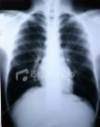

While this is not my lung x-ray, a little note in reading one is that (Ironically) black is often good when looking at one. Any white streaks or smoky appearance are signs of deterioration.
7

Tick tock - tick tock

Months have passed, while miles of treadmill rubber has passed under my feet. I continue to thrust weights skyward. My mindset has remained unchanged and positive as my daily routine has allowed me to continue breath. I found myself to be almost like two people. One example that always comes to mind was when I would be seated in my living room. What was called breathing while at rest, wanting a drink of water naturally I would stand and walk to the kitchen sink. After going perhaps 30 feet, only upon reaching my destination I would first be looking for something to lean on, then I would gasp for breath until I could once more regain my composure. It was during these “Breathless Journeys” that I would realize I was ready for whatever it would take to survive. While the sink is as said, an example I have lived this scenario time and time again. Whether going from a chair to my car, or my car to the entrance of wherever I was bound. Unquestionably, I experienced many embarrassing moments when being asked by good Samaritans, if I was ok. I do thank each of you for your kindness. You have proven that goodwill still exists in the world.
However my worst moments were when my breathlessness began to affect my pride & physical appearance. Something would occur as my stomach & diaphragm muscles tensed & pressed against my kidneys. It was as if my body was squeezing every ounce of air from my struggling lungs. As a result I would lose control of my bladder, soiling my trousers. Certainly there is never a time for this to occur, nor shall I ever want to go through such a horrific ordeal again. The ultimate in embarrassment was experiencing, and now describing this. However I do so for the integrity of this book, but moreover to direct anyone going thru this to simply seek out a local Urologist. A prescription will quickly remedy this problem.
Next, as my Fev1 tests were slowly dropping with each visit to the Shands Hospital, my Pulse Oxygen levels were not. Known generally as Pulse/Ox levels in the medical field this is the percentage of oxygen in the blood. If any medical personnel have ever slipped a device resembling a small stapler on the end of your finger, this is called a pulse oximeter, and you have been tested. This marvel of technology determines if you should be on oxygen to assist your breathing. Ironically, despite my lung function now being around 15%, my pulse/ox remained in the high 90% range. When you’re sleeping your unaware of your breathlessness, even if you believe that you are healthy. As a precaution to protect my organs, I was directed to begin breathing with assisted Oxygen while I slept. For an idea of what is considered borderline, an 88% pulse/ox reading is where Medicare begins paying for prescribed oxygen. The amount then, measured in liters per minute is based on your pulse/ox percentage readings. It is also important to know whether your numbers fall if only when at labor. If that is the case, you would be prescribed oxygen while exercising.
At this point in my journey, it now was May, 2002. Two years had now passed since being declared disabled, and at last my Medicare became effective. So many changes would now take place regarding my care. While maintaining my current insurance company’s coverage, they would become secondary. This meant they would begin to pay a percentage of what Medicare did not. It would also mean their rate would drop literally hundreds of dollars per month for my portion of the premium. Likely, even the biggest change would be that when it would be in effect at the time of my transplant. As such, 80% of my transplant costs would be covered, in addition to prescription coverage for specific drugs related to minimizing my immune system, the rest of my life.
Angels were looking down once more, when I was told about an organization called Patient Services Incorporated, (P.S.I). This group (www.uneedpsi.org) is entirely funded thru national donations, both corporate & private. PSI is one of the "ground breaking" 501(c) non-profit, charitable organizations of its kind. For nearly two decades, PSI has helped people who live with certain chronic illnesses or conditions, helped to locate suitable health insurance coverage and access ways to satisfy expensive co-payments. PSI provides assistance with the cost of health insurance premiums associated with Cobra’s, State High Risk Pools, Open enrollment, Guaranteed Issue policies, HIPAA conversion policies; and prescriptions & copayments associated with private insurance as A and B. Upon going thru another registration process, I was approved to receive their insurance premium assistance. This is yet one more amazing group of people that helped change my life by reducing one of my monthly costs unbearable by almost anyone’s standards.
January 1, 2003, all seemed in place with insurance authorization, pilots on alert, bags packed, all plans in place at home, as well as with the Shands hospital. I had even done research and found an often overlooked insurance benefit which would provide $10,000 in housing assistance following my transplant once released from the hospital. This would continue for the expected several months anticipated stay there. What an exciting jewel that was to have discovered.
We then received a notification that my previous employer had changed insurance companies. This would mean ours had changed along with theirs. Suddenly realizing all pre-authorizations would have to be reapproved by the new insurance company for my surgery, etc. My initial shock would be when they informed me, I would have to change hospitals & transplant programs, to be in their “network”. They insisted they would only cover my expenses if I went to Birmingham, Alabama versus Gainesville, Florida. This was a distance of 700 miles “each way”, versus 300 adding 800 miles to each round trip. Certainly, not to mention having no information about Doctors, their transplant program, survival rate, (or if they even had one!). Further, I would have to be accepted as a patient by their staff.
After much negotiation, they finally agreed to allow my plans to continue unchanged at the University of Florida, Shands hospital. One last sting was that they would not approve of the $10,000. Housing expenses, even though they indeed offered the same benefit.
It must be realized, that there was much more at stake than miles. I knew I would be making the trips to whichever hospital I chose, for the rest of my life. The vast distance would play a big factor in the future, as well as flying time for my initial transplant. Yet, the underlying deciding factor was confidence in the team, and I had made my decision almost two years prior. Another hurdle now crossed, all was back on track.
8

Wake up call

Sometime around 6 am on a January morning in 2003, after 15 months of listening for a beeper to go off, bags packed, plans in place, our phone rang. The voice on the other end calmly asked, Are you ready? My heart raced as I wiped the sleep from my eyes. Sometimes we wait for something, and suddenly don’t know if we are ready when it arrives. A rush of emotion raced thru me, my breath gasped perhaps for one of the last times. The deepest of my fears consumed me, while I realized someone had just died, and my acceptance of this offer could also mean I would be dead in a few hours, or beginning the rest of my life. I chose life, and all the chances of my passing, passed as well. Yes, I answered, “yes”!
James had just left the house for school, and had made it to the corner when he was called back home. It seems his day also was about to go as unplanned from moments ago. He would watch his dad pursue a new lease on life. The next 30 minutes or so was a balancing act of waking my family, making phone calls to my pilot, parents, in-laws, daughter, my brother, and friends. Also, we were making the finishing touches on our packed bags. My in-laws and children would be driving to the Shands hospital, as said 300 miles north. My parents and brother began plans to begin their flights from Michigan to Florida. In those hurried moments, I soon realized this was also my goodbye to everyone. Definitely, it’s easier to be strong than to ponder what if. Twenty minutes, and we were airborne.
Of the many memories of that morning, soaring at nearly 200 miles per hour was that we were in one of the first private planes with a built-in parachute; it was another sign that this would be an amazing day. Upon arriving at the hospital, I was directed to a hospital room which I would use while being prepared for surgery. Next, I was given a bottle of antiseptic soap, and told to take three separate showers. Once completed, I found myself waiting. It felt like hours had passed, and eventually enough time had lapsed to see my in-laws and children. I had always been told there were only a few viable hours to “harvest” the organ. Yet, on this occasion the donor was on life support. Soon I would get the news, the lungs of the donor, were unusable. The trip had been what I now found was called a “dry run”. Once more, things happen for a reason, and that day while being prepped I shared a room with a wonderful Minister. Several new relationships began after meeting him that day. My relationship with him went on for several years; until once more the dreaded news was passed down that we had lost yet another friend. While my parents were now about an hour away, it was far too late to let them know this had been one big practice run.
February 13, 2003 once more began with an early morning wake up call. Just as dramatic, and with all the emotion we had experienced just weeks before my transplant team was once more asking me, “Are you ready“? If I could have even been more at peace, this was the day. My in-laws and children (actually they were amazing young adults), left even earlier while our good friends dropped Nancy & I, off at the airport. My parents had arrived at their winter home, and were also on the way. There was a more pronounced urgency when speaking with the transplant coordinator this time, if that’s possible. Time was of more essence this time, i.e. no one was on life support. Indeed I will always remember my prayers, Nancy’s expression, and feeling like I should be nervous, yet I was not. 90 minutes after taking off, we were landing once more in Gainesville, Florida. I look back and again, wonder if I should have not been so overcome with this confidence. I know we should have been in deep conversation, and there was definitely an 800 Lb. gorilla in the plane with us. One must realize we had made these plans and the ultimate “what if” conversations had been made many times over these last few months, even years. The same was true about my young adults; I just never had the big “Good Bye” speech with them. Maybe in reality having that conversation, would have been more frightening than even the surgery? When I asked them even years later about having that speech, they simply told me I showed no sign of doubt, why should they have any?

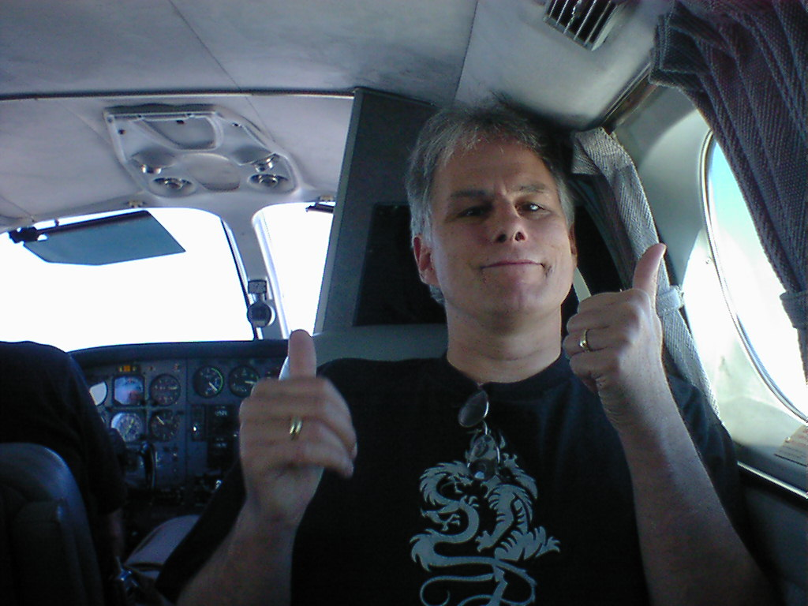
On my way on the “BIG” day

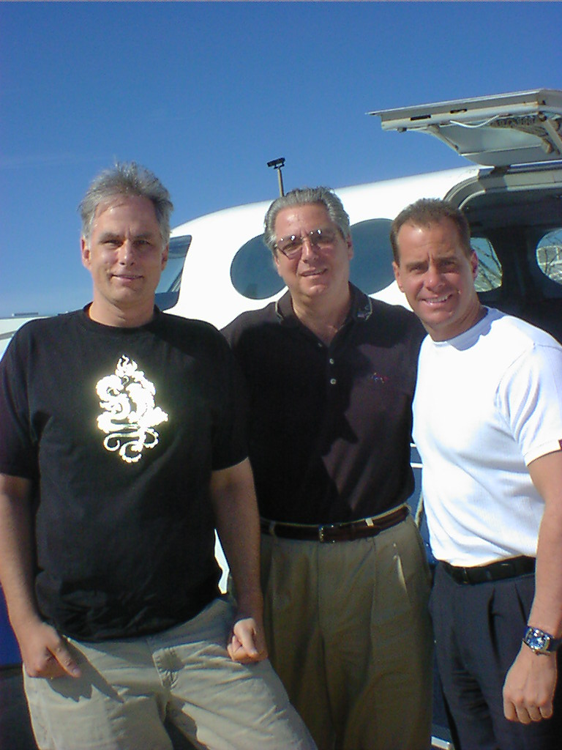
My Angel Flight Pilots

A quick ride to the hospital awaiting transportation, I found myself being rushed thru the emergency room by surgical staff already in their gowns. This was very different than my experience just weeks prior, and even no room was available for my prep, other than a small room divided by a sheet in the E/R department. After being set for my ride down the hall, I waited only moments. Fortunately, all my family met with me in the hallway at the surgical door entrance, once more I found myself assuring everyone I would join them soon.
Many times I had stated to them, I had the easy part in all this since I would be sleeping. I feared more for them, pacing the floors for the expected 6 - 8 hour surgery, as I remember being rolled under a massive light. I listened now nervously as a very crowded room full of attendants and doctors scurried around me. Their tools clanged, as they spread them across a large table. If my nerves were ever on end, it was now. Perhaps, if only for a moment lying there in the bitter cold room, I felt the little boy inside me and he was frightened. One last prayer under my breath gave me, and that little boy, peace. Luckily someone must have realized this as well & slipped me something juicy around this point I was now in la-la land.
Despite my efforts during the months leading up this surgery to view a video of an actual lung transplant, my efforts were unsuccessful. After being told that no video existed, I had even volunteered to have mine taped for teaching purposes, yet this was also declined. As such, to the best of my knowledge while sleeping, the following occurred:
- A central venous catheter was inserted into a vein in my neck. This type of catheter was used to deliver fluids, nutrition solutions, antibiotics or blood products directly into my bloodstream without frequently having to insert a needle into my vein.
- A tube was then placed in my mouth that went down my throat and into my windpipe (trachea) to help me breathe. The tube is attached to a ventilator that expanded my lungs mechanically.
- Then I was placed on a heart/lung machine to allow the surgeon (Dr. Staples) to bypass the blood flow to my heart and lungs. The machine pumped blood through my body, removing carbon dioxide (a waste product) and replacing it with oxygen needed by my body tissues.
- A nasogastric tube was inserted through my nose into my stomach. This tube drained all secretions.
- A tube called a catheter was then placed in my bladder to drain urine.
- In my case of a single lung transplant, the lung that is most damaged is the one that is transplanted. This was determined by a test called ventilation-perfusion scan, which showed the blood flow to different areas of the lungs. Areas that indicate less blood flow are the ones with the greater damage. As such, my left lung was removed.
- I proudly had already received permission to become the first “Donor” giving my lung to the A1Ad Research Team within the University. It soon was distributed to laboratories around the world for testing
- The “donor” organ, had been chilled to preserve it during transportation from somewhere in the state. It also had to be transplanted within four - six hours after being removed from the donor. Amazingly that surgery was $ 47,000. This was also added to my bill. While the gift is unquestionably priceless, I did wonder if other organs were also offered, and how that billing must have worked. Furthermore, it seemed only appropriate to me that if somehow the donor’s funeral costs could be paid thru these funds, more donors would be inclined to offer.
- As soon as the new lung arrived in the operating room, my lung was immediately removed and the donor organ was placed in my chest cavity through an incision (to my surprise along my shoulder blade though my back).
- Finally, Dr. Staples connected the pulmonary artery, pulmonary vein and my main airway (bronchus). Several chest tubes were inserted to drain air, fluid, and blood from my chest for several days to allow my lungs to re-expand.
- Multiple “staples” were used to close the incision (what else would Dr. Staples use)?

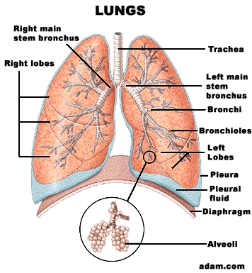

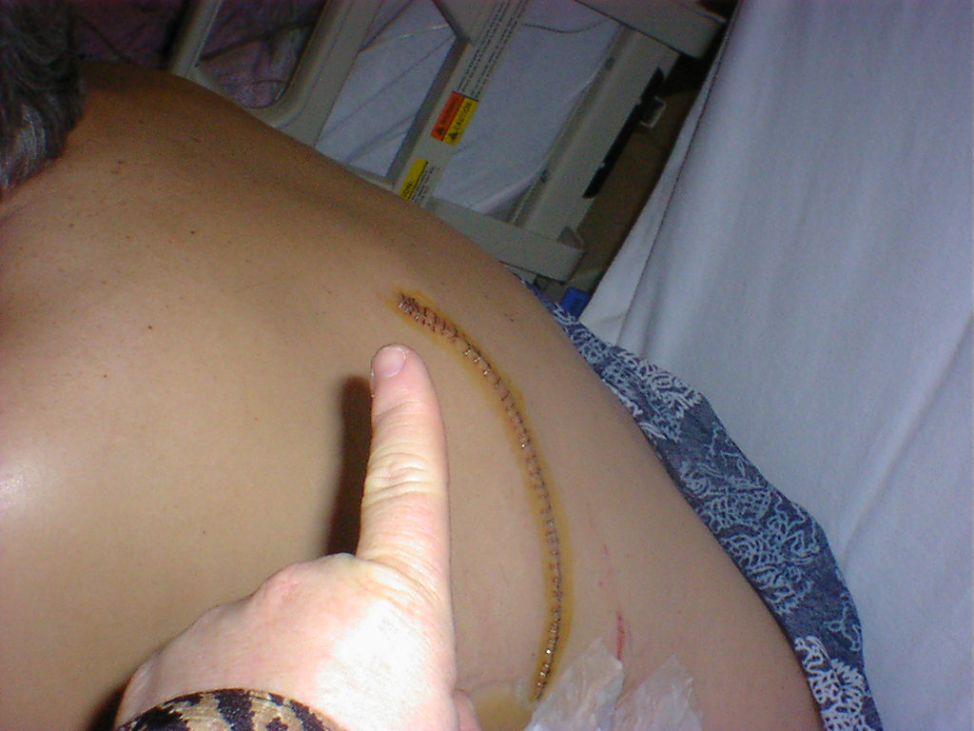
My Ouchie
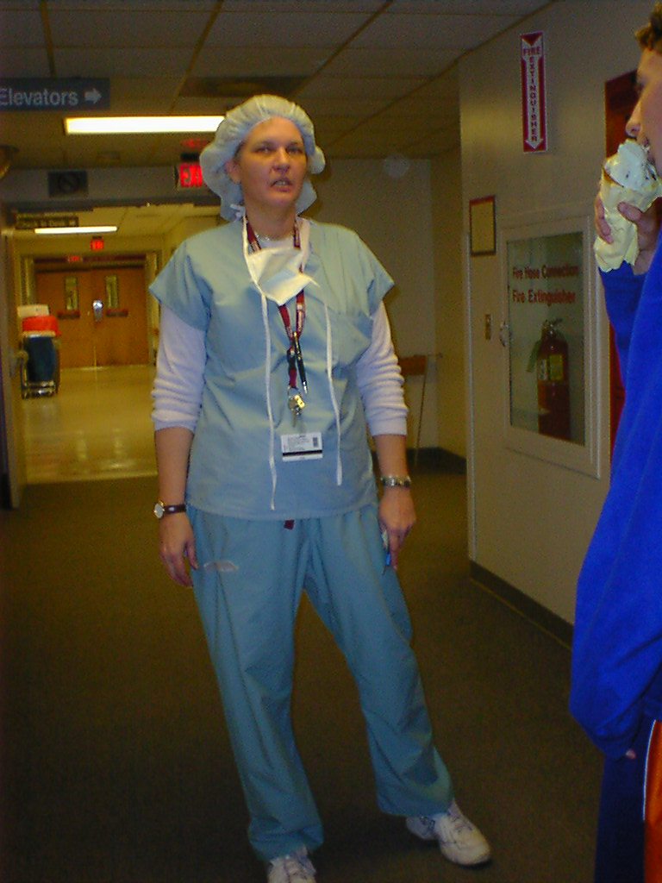
My transplant / surgical coordinator
9

Take a deep breath

So many times over the past five years, I would awaken and lie in bed imagining what it would be like when I would awaken from my surgery. Would I take a deep breath and smile uncontrollably at the difference? This was the magical morning, and what a gift on Valentine’s Day. When I awoke, the only thing I might not have recalled them telling me, was the intubations tube would be down my throat, as well as tubes in my neck. Being not able to speak was a bit frustrating, but was nothing to have been concerned over, I was “ALIVE”.
The biggest news I was to receive was that I had received a single lung transplant. I had been obviously curious about this for a number of reasons, but the decision would not be definitely made prior to surgery. It is often the case that if two lungs are available, they try to save two lives. While other factors come into play, a person may receive a double lung transplant also if no one is compatible at the time. It may be as simple as a team’s decision based on one of the lungs being damaged in the donor. Foremost, if a double is performed, the entire chest wall is opened from the front. The rib cage is then opened wide for surgical access. I was initially informed, that if a single lung transplant is performed, the incision would be from the back and wrap around the side to the front. It would be approximately, twelve inches in length. I awoke with one new lung, and a much smaller incision than predicted. I was also given assurances I would be able to do almost anything I chose to do. Above all, I was blessed.
I had my share of lines, electrodes, & monitors but my zest for life was obvious with each thumb’s up sign. The only frustrating memory I had in I.C.U., (Intensive care Unit) was at one point when my remote control for the television had fallen on the floor. The tube in my mouth still prevented me from speaking, (or singing ), and no one seemed to get the message. Despite previous estimates that I would be in Intensive care for at least a week, I was released to a private room after only 1 ½ days.
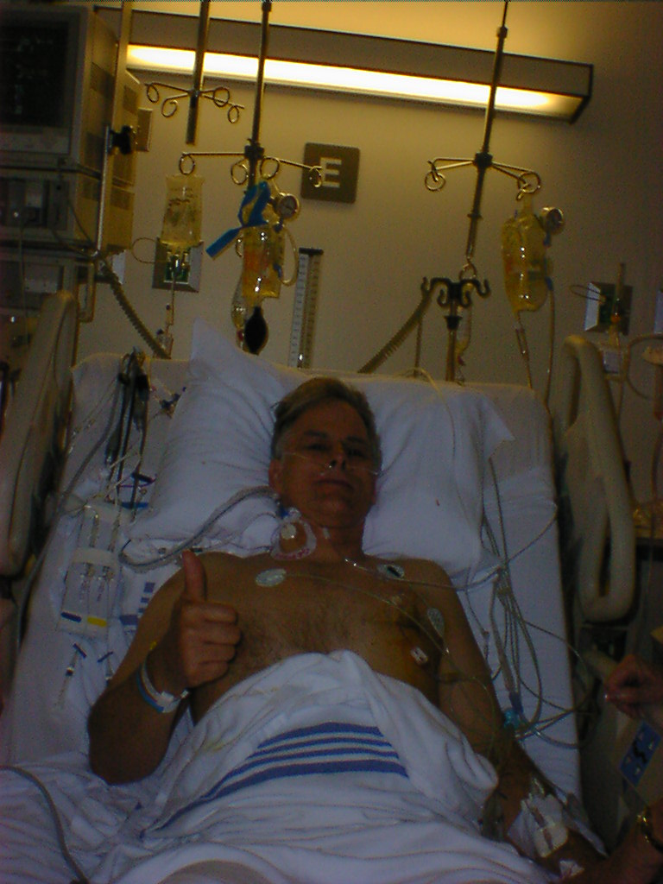
I.C.U. >>>>> The 1st day of the rest of my life

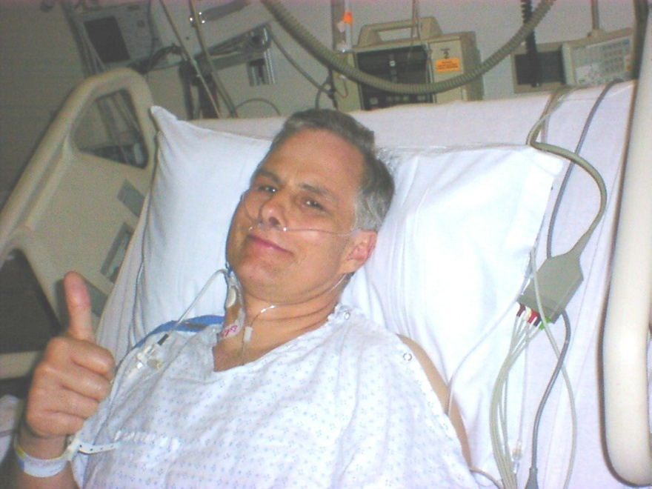
I will deal with most surgery’s, I just hope none involve my thumbs!

At this point, I am so amazed at how smoothly this ride has been, just like the jet ride here, “no bumps”. The food is even delicious, contrary to all the common hospital jokes. Frankly the worst part of this memory was that involving the chest tubes. As delicately put as possible, they are inserted obviously through the chest wall atleast8 inches long, and wider than a garden hose. It is then placed along the outside of the lung for drainage. Their removal and my release from the hospital would be based on their use, as well as my work in physical therapy. The very following morning of being in my own room, I was directed to begin walking on the treadmill & lifting weights. My progress there would dictate how long it would take of the estimated three months, before I would be heading home.
Ironically, the most painful memory I had was three days with constant hiccups. With each hiccup, I felt a jab as if they tubes were being re-inserted over and over. As mentioned earlier, when estimates were being made as to how long I would be in the hospital, I was told 3 weeks to a month. Proudly I left the hospital after 5 days, even breaking their record for a transplant patient. In fact, my stay was so unexpectedly brief, we were forced to find an apartment far earlier than planned. Another wonderful thing about the Shands Hospital had been that they provide accommodations for family right in the hospital rooms, so the race was on even for Nancy. Before being allowed to leave, I would also be educated & quizzed on all my new medications. Everything I had been taking prior to the surgery, from inhalers to Prolastin would no longer be part of my regime. In their place, were eventually 14 new prescriptions it would be life saving knowledge to know what I was taking, how much, how often, why, and forever. As simple as possible, they consisted of Prednisone (a steroid with a list of side effects). Several Immunosuppressant’s to keep my immune system as weak as possible, tricking my body not to attack my new organ. Blood pressure pills to fight an increased heart rate. Anti-gas pills to keep acid indigestion from bubbling up and also invading the new lung. These are some of the regime, but you might have caught the pattern that most pills require more pills to fight the side effects of each other.
Once our apartment was picked and ready, I walked out into the world and took my first breath of fresh air. Yes, I felt like a movie star.

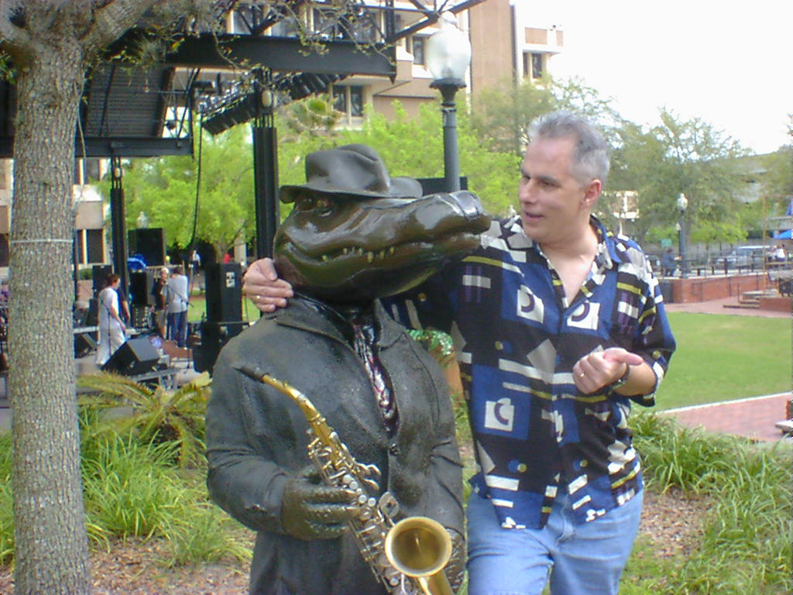
My first walk in the park

My trips to rehab were daily, my push was sincere. Something in the surgical process had wiped out my speed, and lying in bed weakens your muscles. It had been taught to be for months before the operation, that your lungs don’t get you out of bed, your legs do. How correct they were. My breathing was steadily climbing, I was told it would take 6 months before I reached my max potential. My goal was to walk thirty minutes consistently to be released from my rehab requirements. Evening walks, in addition to little outings around the city (as with the picture above) would soon bring me to where we all wanted to be. All other medical evaluations were in order. My medications were in balance with my blood work. Finally, pictures & peeks into my new lung with a camera, and samples analyzed through the process called bronchoscopes. In six weeks, half of the time again estimated, I got my “golden ticket”, we were on our way to “home sweet home“.

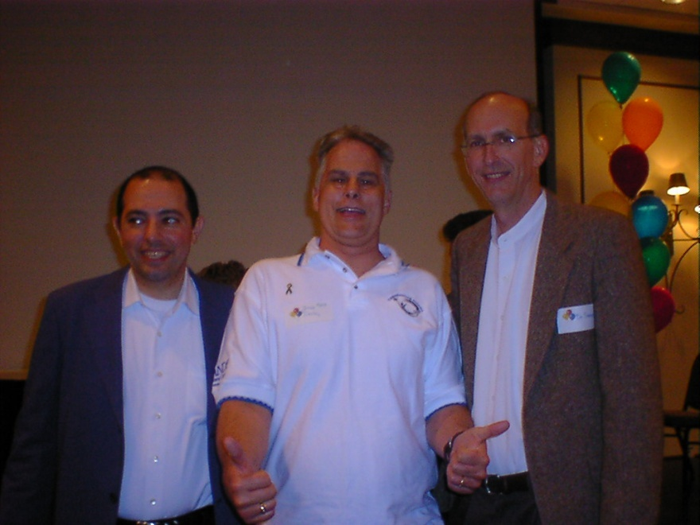
Dr. Baz Myself Dr. Staples
(Lung Transplant Dir.) (yep, my Surgeon)
10

Live like you were “not” dying

The ride home was such a beautiful one. I had made these trips a number of times, but this time I smelled every flower, admired every flying bird, o.k. maybe not each one, but you get my point. Freedom tasted good today, as I came closer & closer to my home. No, I was not in your typical jail cell prior to taking the trip. In fact, I thought I was living to the fullest. Yet, if I had any secret concerns about surviving my surgery, they were gone today as the world rushed by outside my window.
Many hills awaited me to climb, but I felt confident I would be less breathless as I met each challenge still before me. Before I would be working up a sweat, I had some celebrating to do. What better than to meet up with all those waiting at my home that had watched me get to this point? My sister in law had been living with my son, as they kept our home in superb order. Our daughter, parents, amazing friends, even the dog were welcome sights at last as this phase of my magical journey ended. I have no idea how many angels had been with me these past months, or years, but they certainly had been near.
I would be making many adjustments in this new life, sanitation was crucial, and masks when the situation demanded.
Physical or pulmonary rehab would be with me forever. Watching, foods & air quality were also amidst my top concerns. Of course, singing would continue to be my favorite lung exercise. Ironically, the two forms of rehab would soon meet in one place. I was honored to host as musical entertainment, at the hospital picnic where I had previously worked out. I continued my rehab there, and once again made lifetime friends in the process.
I never really stopped and counted our Shands trips until the following January. While doing taxes I realized I had made 11 trips to my team during the year of my transplant. Most were routine, and continue today every 3 months. They each consisted of multiple blood work tests, chest x-rays, breathing tests, and measured walk tests. Each is then followed by a visit with the doc, and hopefully I would receive a gold star. During one of these tests, I achieved my best fev1 when I hit 50% (or blowing 2.00 liters in one second). Considering a perfect test for someone comparable would be 4.00 liters with two lungs, it showed my new lung was at max, while my old was at zero.
Other visits were for bronchoscopes, wherein a camera is used to take pictures of my lungs, and samples taken for lab testing. I found myself being hospitalized unexpectedly on several trips, once spending a week getting my immune system blasted with meds to hopefully further weaken it to prevent rejection.
Once again, things happen for a reason comes to mind. I met a new friend during this stay. At First, I was apprehensive to have to share a room with a stranger. As hours turned to days, then a week, I found once more I had gained a new friend on this amazing journey. Emails, phone calls were exchanged over time as well, until one day we found yet one more soul had passed through our midst as he passed away one regretful day. Terry, you will be forever missed.
Yet another unexpected weeklong stay was following another bronchoscope of my new lung. One risk during the procedure is that it can become punctured, basically causing it to “deflate”. Following the bronch (as often abbreviated in the field), I became immediately winded when I tried to walk. A bigger issue than normal, when only one lung was pulling the load. It is called a neuro thorax, when a lung bursts, or receives a puncture for whatever reason. In my case, it was pierced by accident by an overconfident doctor had actually been dancing to rock & roll, while bragging how fast she was at these procedures. I was under anesthesia, while all this occurring but my wife had been allowed in the room on this rare occasion, learning why spouses are not allowed during medical procedures, “we learn too much”. Let’s just summarize to say I insisted on never having this doctor do any procedures on me again. While I could have probably now owned a piece of the hospital, it was more important to me to have good relationship with the team that would forever hold my life in their hands. I spent another week in the hospital due to this adventure, during which time my son had called to advise he had awoke one morning to a flood in our home. When it rains it pours, as they say. The crisis had passed, or so we thought, when the source of the leak was discovered and repaired.
Speaking of relationships, an annual event is sponsored by the transplant team, inviting all transplant patients & their families to a local resort. The picture to follow was of the first I had the pleasure of attending. During the duration of the transplant program over ten years at the time of mine, I became # 203. All who could attend were brought on stage for this group photo. Throughout the evening we shared stories, health information, and grew bonds with new & old friends. Each year we look forward to the gathering, but as circumstances happen we too have had to miss a few years due to timing restraints. Nonetheless, we continue to grow bonds with all who have so much in common.

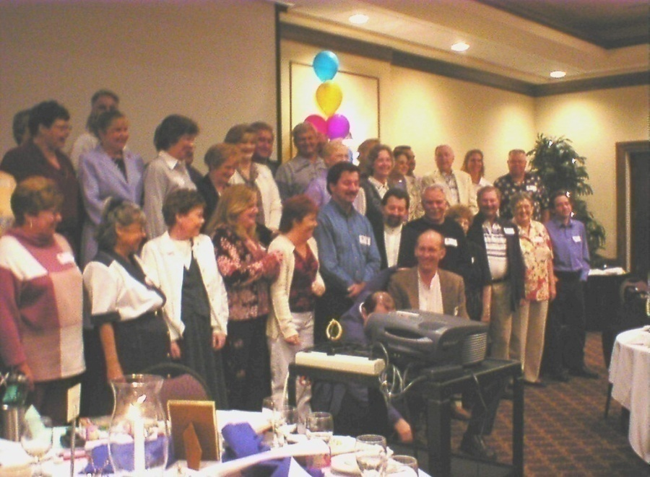
My 1st year “Lungiversary” while sharing with my Shands lung transplant reunion group.
11

Check in time

While the first year involved a eleven trips to Shands Hospital, I felt sublime in my life. I continued with my pulmonary therapy, and walked as often as possible. However, hints of a disaster were about to reveal themselves around my home, when a white powdery growth began to form on the woodwork trim. Further and further I began investigating the borders of my hallway, kitchen, and living room realizing the powdery substance was in fact mold. Upon removing some wood paneling on my hallway walls, I found I could actually press my hand “though” them and find mushy insulation. It was now when I realized that the flood from a few months back, had actually been going on for an uncertain period of time before flooding the floors. It had been originally caused by a pinhole leak in an ice maker line to our freezer. While the line was repaired while I was still hospitalized, no one could have known the interior insulation of my walls had been sucking up water like a sponge. In the end result, we were forced to file an insurance claim. We were told we would be out of our home for possibly two or three months. After moving into temporary housing, our home was gutted. One room after another was determined to have signs moisture in their walls, or floors. Soon, every room with exception to three bedrooms, were concrete & studs. After every imaginable delay, including hurricanes we were still displaced from our home 16 months later. Alas, amidst threats of law suits and press coverage we were home once more nearly 1.5 years later.
Certainly, medical events would occur during those 16 months and beyond, to break up the boredom of our “normal life“. I would do my little part to keep the Hospital in business, as well. I found myself enjoying the hospitality of the Shands Hospital staff twice in 2003, in 2004 - 2006 I would join them seven more times, averaging $ 75,000 per visit.
The third started so simple, a red irritated area below the knee. Incredibly, it took five ultrasounds (the use of sound to create a picture of what is happening below the skin), lots of speculation & several doctors’ involvement to nail the final diagnosis. After the first ultrasound, I was hospitalized under the premise it was caused by a skin irritation called Phlebitis, or Cellulites. Again undergoing three ultrasounds while admitted, all reported negative findings for blood clots. After five days, and multiple antibiotics I was allowed to go home and monitor the area. Over a weekend, a red line formed, and raced up my leg. “A picture is worth a thousand words”, was never truer than when I emailed a picture to my coordinator. I received a phone call, instructing me to immediately return for another stay. One must always keep in mind, without a strong immune system anything amiss in my body, from a cold to cancer, can grow furiously in my body.
Upon arriving, I was rushed to my fifth ultrasound. Dr. Baz pursued the results immediately, and all finally concluded I had a blood clot headed to my heart. It seems blood clots are normally closer to the surface; mine ran deep or vice versa. Once more time my life was saved, as blood thinners were administered. Earlier in my story, I told I had lost my twin instantly, due to a blood clot. I, along with my parents, sister in law, and so many relatives, had experienced another heart breaking loss, when my half-brother Ron also suddenly passed away just before my transplant. It was further determined he too, has a blood clotting problem involving the heart attack that took him. As a result, a family history was beginning to unfold and I shall forever add blood thinners to the regime of prescriptions that keep me thriving. Ron, then become yet another in what we pray are an army of angels overhead. Watching, protecting, and at peace over each of us.
My fourth hospitalization will be a bit more dramatic, as I was making a normal visit to my local G.P., Dr. Hays listened to my chest, became serious, reached behind my leg and said do you feel any pressure here ? Wow, he sure nailed the spot as a shock went thru me. He urgently insisted that I immediately go for a MRI (Magnetic Resonance Imaging) is a cross section image using radiation, basically an extreme x-ray of my lungs. Once arriving there, while waiting for my name to be called, I stepped into a restroom. An attempt to urinate “blew my mind” and instead I was passing pure blood thru my kidneys & bladder. I probably experience my biggest fear yet, as I stepped out to the desk, and whispered to Nancy “Things just became a lot more serious”. Confessing to the staff, I was rushed for my MRI. Arriving there the technician took the images, and “further freaked me out” by saying I hear you’re doing some flying to Shands today. Well, I did not have to fly but likely should have. Upon arriving in North Florida I was told my organs were saturated, and my lungs were half full of blood. It was so thin that it was seeping through the walls of all my organs. Over the next few of another 10 day stay my blood was thickened. As it all turned out, instead of taking 2 mg. a day, (4 x .5mg pills) I had been taking ten times my required dosage, which was 20 mg. This was caused by my taking (4 x 5 mg. vs. .5 mg pills (½ mg)). This had been going on almost two weeks, as I separated my pills in two week pill containers. This mistake will never happen again as I disposed of all 5 mg. pills. I also learned that day, that blood thinners come in different colors. It also seemed the prednisone had been causing my eye sight to diminish, causing the misreading of the prescription bottle. One more case of Angels & Doctors saving me!
Standing up one day, I had the weirdest feeling as it felt as if the ball of my hip did not seem to set properly in my hip socket. Time and time again over the next few days, I would essentially have to shake my leg to walk properly. Pain began to follow these instances. As I continued to describe this as if the ball was dislodging itself from my hip, once more I found myself speaking to Dr, Hays. I received an x-ray as he proceeded to tell me I had: A vascular Necrosis (Greek for death of the bone). Briefly, this is caused when the blood vessels to the bone, the ball of my hip in this case, are closed off. The blood flow stops, the bone dries up and begins to crumble within your body. Next, I was told that it was being caused by the use of, prednisone as well. Further, he informed me the only remedy would be “two total hip replacements”. My journey had already taken me down so many strange paths, for the first time I simply (initially) refused to deal with it, even laughing I said “no way“.
Oddly, thinking back I was reminded of a story where human body parts were arguing with the brain as to which body part is the boss. The heart demanded it was the boss because it kept the blood pumping. The eyes demanded that they were the boss, allowed the body to see where it was going. The legs insisted that they were the boss, carrying the body from place to place. The Anus spoke up saying it was the boss, and all the other body parts starting laughing at it, for being so absurd in its logic. It became so embarrassed & upset that it puckered up and refused to open for many days. Soon the eyes starting watering, the legs began to wobble, the heart began to race & flutter. All body parts finally gave in, agreeing with the anus, proving “You indeed have to be an Asshole to be the boss“.
I could not help but throw in that antidote to emphasize; within days I could not walk any further than a few baby steps. While doing so, it took forever to go short distances, and in excruciating pain. I had no choice but to reconsider my initial first reaction to not deal with A.V.R. (Avascular Necrosis).
In July 2005, I was making another visit back to Shands, this time in the orthopedic center. I was meeting with their head Surgeon, Dr. Gearin. Now, enduring another MRI, this time of both hips, he concurred with Dr. Hays. AVN (A Vascular Necrosis was the correct diagnosis). Once more, my local general practitioner, (family doctor) Dr, Hays nails yet another diagnosis. He, and Dr. Baz have been so amazing thru all the trials I have put them through, I am so blessed to have these life savers in my corner! Further both hips showed the disease, meaning I was just beginning a new path toward two total hip replacements. A waiting list existed of over six months, for the next break in his surgical schedule. This meant soon I would be wheelchair bound, awaiting my surgery‘s. Following each surgery, I would be unable to walk without a walker, or then crutches for up to six months following each separate surgery. Of course, two hips meant I would not walk unassisted for two periods equaling possibly six months.
I headed home under this impression, until receiving a phone call a few days later. In this call I was being offered a date that has just became open. The date would be set in one week, how could I not say yes? So, I made my preparations for another life altering event. During the surgery, the ball was removed, as well as the femur (leg bone) being hollowed to the knee. Then inserted was Chromium metal ball & shaft, and screwed into the leg femur. The following morning, my favorite folks, physical rehab technicians were knocking at my door for the first of many walks & workouts. Eight days later, I was being released, with what was thought to be a somewhat normal problem. My wound of about eighty stitches was still bleeding. Arriving home, I was still bed ridden, with rehab and home nursing visits daily. A week passed, my bleeding was not stopping, despite many suggested efforts, including large sand bags to apply pressure to the incision. After my wife’s insistence stating that something was wrong, including my pale appearance finally prevailed, and I was readmitted.
Arriving once more, following tests it was determined I would have to have the incision reopened during surgery, as well as having the entire piece inspected for infection. Basically, it was a repeat of the first surgery. It was also found that a pocket of blood had developed, it was closed up and once more I began the healing process with a new “drier” incision. It was also determined, I had lost over half my blood, and another miracle saved this man’s life. Ten days later, I was again home to begin my healing. Eventually progressing from a walker, (bless anyone you see using one, for you can bet they would rather be racing you down the sidewalk), then from two crutches to one, I finally was walking unassisted once more after three months of work.
I have received so much love and concern from everyone in my life. Family, friends, even strangers in many cases that had cared and worried over me, yet they were instead losing their lives all around me. My heart broke seven more times in the period from July to December of 2005. During this ordeal, Jean, my aunt, had pushed so diligently to promote my compact discs as fund raisers while showing me love all along the way. Dan, My best friend since childhood, whom was afraid to listen to my cd fearing he would never hear my voice again if he did. Tracy, an Alpha friend who underwent two lung transplants and more complications than anyone should have to endure. Nancy, now another Alpha angel was suddenly lost after a liver transplant. Gayle & Jimmy, sadly a mother and son passed within months of each other, and had been neighbors & friends for twenty years. Ultimately this day shall be the saddest of all, when informed our daughter had passed away in her sleep just after spending Thanksgiving with her days before. No parent can ever recover mentally from this. In my heart I feel, time does not heal, it burns. All these souls had loved & prayed for me. It shall be my greatest challenge to continue to maintain the spirit I have become so proud of, the strength to show all around me that I will not quit. My family sustains me, my Lord has plans that I cannot begin to understand. Each day I will continue to try to prove myself worthy of the faith all have placed in me, while praying for the strength to do so.
Many months passed before I could bring myself to sing, yet I do so now for all who encourage me never to stop, and through stories I know my daughter is one that wanted me to continue with my music. My lungs grow stronger, or vastly slow the deterioration I am destined to accept with each song. Further, as I sing almost daily to a worldwide audience on a website called paltalk. (www.paltalk) I continue find treasures in the friendships and encouragement I also have found there.
As six months had passed, I had begun feeling the symptoms of now my left hip giving out. This was especially true since much of my weight had been forced to the original hip. I had already scheduled a surgical date when I planned on doing my right side, and the time was here to decide if I was ready to “start over” on the other hip. If I chose to cancel, I again faced the prospect of further pain and being wheelchair bound until the next opportunity availed itself to me. Considering how suddenly I could not walk previously, I made my plans to grin and bear it, once more.
April 2006, I checked in for my eighth time since my transplant, to have now my left hip replaced. Much to my satisfaction and partially due to my familiarity with the procedure I faced very few surprises, or so I hoped. Following my surgery, I again poured my enthusiasm into working out with my legs. Ten days later, I again was on my way home to South Florida. The following x-ray will show the extent of what both procedures involved. Now, over $200,000, Had been pumped into just my three hip surgeries. This edged my medical bills even closer to making me the “Two Million Dollar Man” to the University Of Florida. I should also mention that once you become a patient of a transplant program, they become your Principle Physicians, in explanation why all surgeries were done so far from home. I also, am again so grateful to those friends and family members that traveled these distances time and time again, to simply show they care. Upon my annual follow up visit, I received a good report after new Mri’s, but informed my new hips would only last 10 – 15 years based on how well I use them. I can take pride my attitude knowing most of my trials give me a practice run. As always one must look to the clouds for the silver (or chromium) lining, I quickly sat down not to wear my new hips out any time soon.

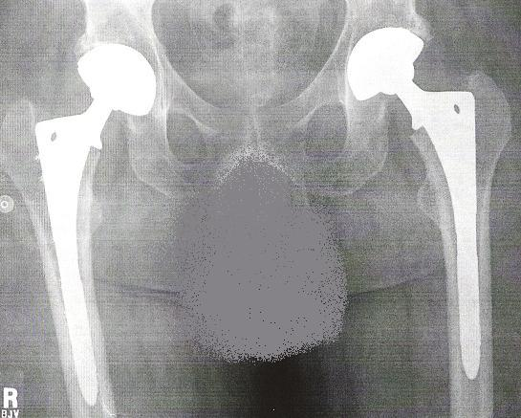

The final x-rays of my dual Total Hip Replacements

Three months as planned, ended my progression once more from a walker, to two crutches, then one, alas “yeaaaaa” I was walking!
The greatest test once more, is when one realizes those around them that have given aid in so many ways. Nancy unquestionably showed me how priceless and necessary a caregiver is. While, she would never accept any of my thanks, one must realize embarking on most of my surgeries would have been a nightmare without assistance.
On that note, comes my son James. When this journey began he was thirteen. I was reluctant to refer to him in no other manner than a young adult. I have watched with pride as he turned into a man, earlier than perhaps he should have had to. As time went on through my breathlessness, so did his willingness to do all the things I found I could no longer do. I can’t deny my self-pride was slowly chipped away over the years when I would need help, but it was also quickly replaced by the pride I had in my son.
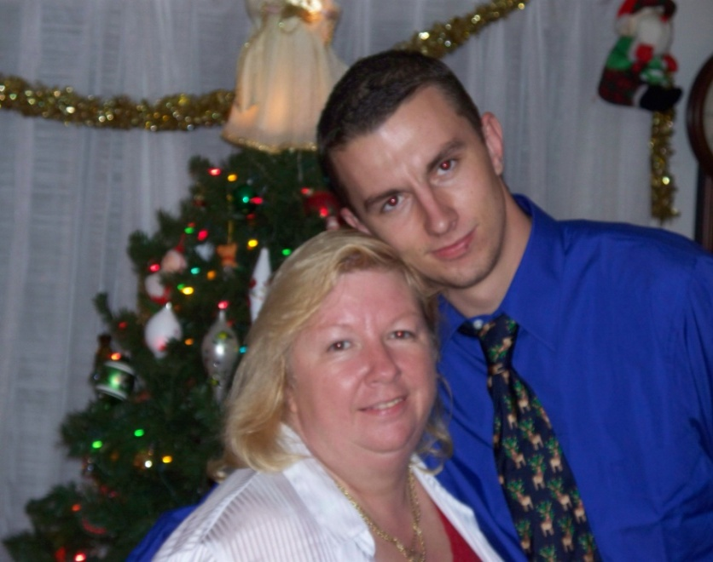

Nancy & James
(I could not have survived without your help!)

12

Keep singing

Life at home has now been consistent, but in the midst of my surgeries, & miscellaneous adventures my inability to work out on the treadmill had likely taken a toll on my lungs. I had maintained my appointments with each three month cycle with Dr. Baz. Unfortunately my fev1 levels had consistently dropped as well. At its peak, my best fev1 was 1.91 liters, (Again 4.00 perfect with two working lungs). 3.5 years later, I had dropped steadily to 1.4 liters. As such, in June 2006 I had been asked to meet with my team. At which time, I was notified I was in rejection. In short, my body was winning the war it had launched upon my new lung. I was placed back on the National lung transplant list for now a second lung transplant. Just as I have said whenever asked, this only means the first time was just for practice and I am as eager as possible, to sail thru my next transplant. Hopefully, to beat my own records set in 2003. My zest for life prevails; my music helps me soar while hopefully bringing smiles to anyone in earshot. And moreover, I continue to work out three days a week with an incredible set of professional pulmonologists & therapists.
My next challenge would put me in a mindset few men find themselves facing. If I had not proved myself as an original as of yet, now facing breast cancer certainly would push me closer. I began developing lumps in both of my breasts, one side much more prominent over several months. While secretly wondering if I was entering my next drama, I knew that if indeed I had “it” several roadblocks would be in my way. First, my immune system would not slow it. Ultimately, I also would not be allowed to remain on the lung transplant list. Realistically, with these factors in my way, this could my greatest challenge. I found hope in both doctors’ impressions that they were benign. My X-rays, and then another MRI also appeared hopeful. They brought me consistent pain, which I also was told was a good sign determining malignancy. In the same timeline, another alpha friend with an identical scenario was told he too should likely not worry. However, following his biopsy he was told indeed his was malignant. A brief time later he also passed away from pneumonia. While mourning yet another loss, this forced me to want biopsies and have both removed as soon as possible. All went well, and I express my heartfelt concern for any woman, or man that also undergoes this mental and physical rollercoaster. Obviously, to lose such a battle sadly creates yet more heroes in the quest to cure it.
Finally, our latest and hopefully last dramatic bit of drama came just months short of my fifth “Lungiversary”, (Yes it’s a word I made up). Incidentally, following my transplant the 5 year survival rate was 50% (minus 10% each year one survives). This was a rear end collision which totally destroyed our car. God once more had to be looking out for us, as were slammed by a street painting truck while he was traveling around 60 M.P.H., while we were stopping to turn. Healing back injuries and required therapy are what now remains of yet is one more reason to keep a positive outlook during my journey, “we’re alive”!
Early in my story, I had shown a poem I had written to explain my condition, as well as to honor my donor. About a year after my transplant, then again after three years I wrote to the donor’s family in hopes of getting a return letter. I never received a word. You must first realize that amidst rules of contact, I could not include any personal information regarding my name, location, or any indication of who I am. Only after the family replies with their information, am I allowed to supply mine. Until then the correspondence must then go thru national transplant network as unnamed.
I will now close, as I can’t imagine a more fitting way than to give you one more peek into my heart, than by showing you the letter I wrote to my donor’s family. Three thoughts prevail, one is that I still hold true to the words you have read, and all those that follow. Second, following my next lung transplant I will honor my new hero with equal admiration. Finally, please become an organ donor because like your money: “You can’t take it with you” & the person you save will love you for it!
Dear family, January 1, 2004

So often I have wanted to start this letter to you, there is so much I wanted to say. How ironic, that I find myself sitting in silence listening to the soft click of a second hand on the clock. I can only begin to express the beauty of your family’s gift to me, and my family, through words of gratitude.
Every stroke of the second hand is another gift. Each is another reminder to me quite literally, of another breath. I am the recipient of the left lung of your loved one. I can never begin to express enough, my sadness for your loss. But, I want you to know that for over three years since being diagnosed with my illness, I began honoring my hero. After being told my only chance of survival would be a lung transplant, I began honoring him or her, in a poem which has now been nationally published several times.
I am the father of two children, ages 22 & 16. I have been married 23 years to a woman whom I doubt I could have survived this without. I, as well as my family, parents, in-laws, and many loved ones and close friends have asked me to try to convey their appreciation. We understand what an emotional price you have paid for being a part of the donor program has been.
I do not want this letter to be a conclusion, but rather a beginning to knowing anything possible about my hero. I shall hope for any correspondence that you are comfortable sharing with me. However, I can absolutely respect your privacy and pain as well.
Just please know that just as I began this letter, that every second, every breath in my life will be a reminder to me to never forget what I have been given.

You will never be forgotten,

Thank you

Epilogue

I began writing my story, with the hope of helping someone that may have been handed an identical or similar fate as mine. I wanted to show that nothing can crush the spirit of survival, despite mountainous roadblocks. On virtually any day during “My Breathless Journey”, it would have been easier to call in sick versus going to therapy. Perhaps riding the Motorized cart through the grocery store, every chance I could get instead of walking as far as I could before pausing. I told of the adventures in my story, absolutely not to receive sympathy. It simply is how my life played out during this period in my life. Most certainly yours will be much different. My point being: keep on singing, laughing, loving, or whatever it takes to keeps you alive & happy. If not for yourself, then do it for those that need you.
Life is not what makes you, it’s what you make out of “it“. Never will I be able to show the true measure of gratitude I have for all those that have helped me down this road. However, with a relentless spirit and my sometimes still breathless voice, I will pour all my being into trying to do just that. Possibly, two donor lives will be lost during the journey to give me breath. I can’t begin to share the weight of feeling those losses with you.
However, I hope my words someday find the families affected by these losses, finally knowing my hero’s will never be forgotten
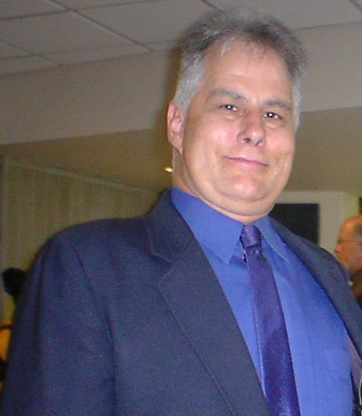

“Thank You”
For
Taking This Journey with Me!

